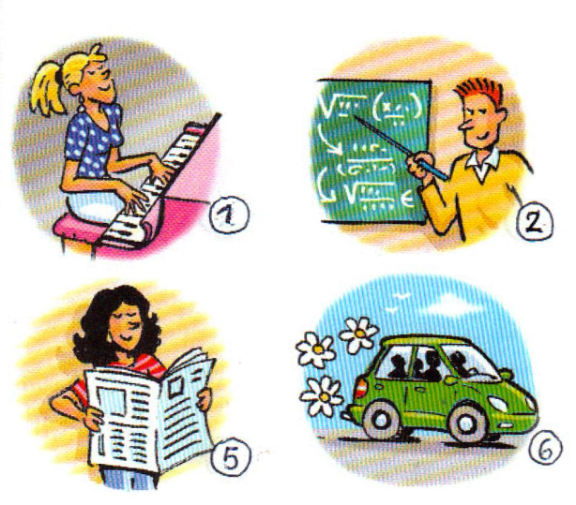
Cuando sea mayor, (yo) …..

__________________________
__________________________



 
 

 
 

