Clase : Nombre : Apellido :

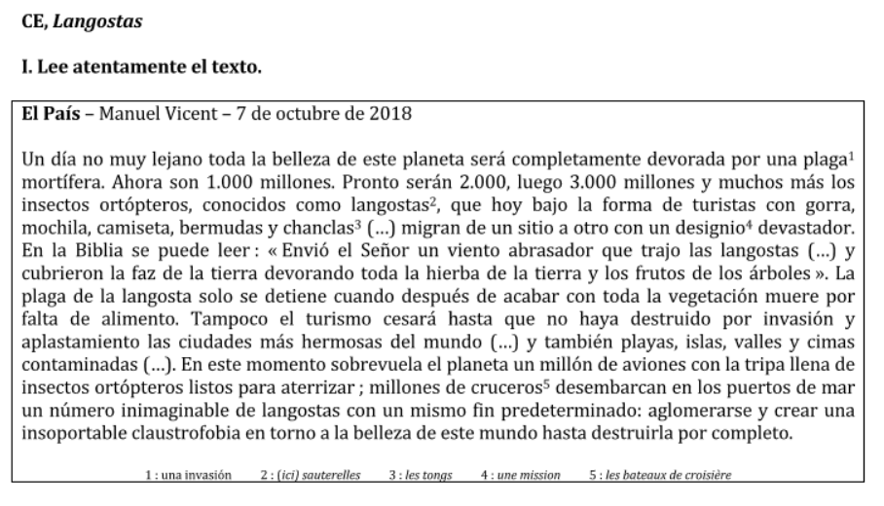
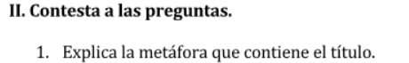
__________________________________________________________________________________________________
__________________________________________________________________________________________________

__________________________________________________________________________________________________
Citas del texto | Tus explicaciones o ejemplos
…



 
 
 

